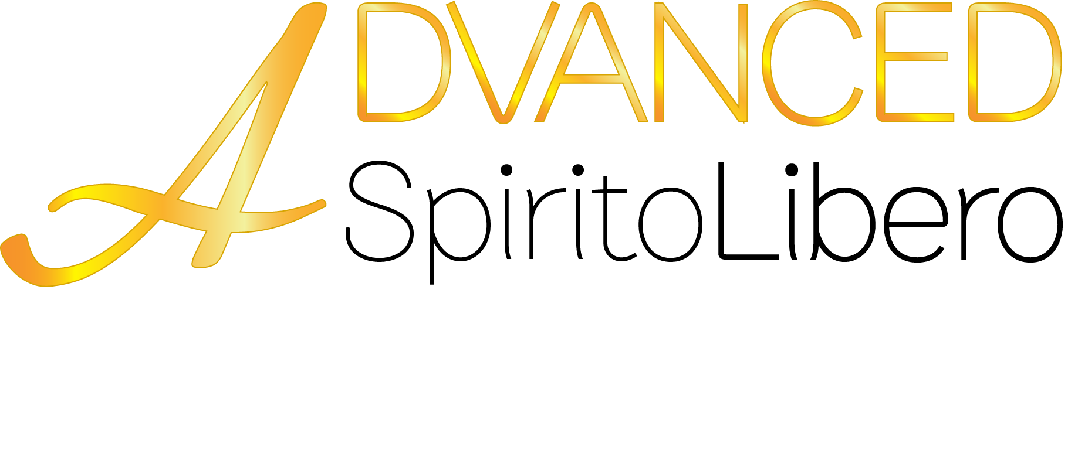

Spirito Libero

sect. 1.0 Technical characteristics
Spirito Libero is a designer stucco which creates a simple, clean wall brimming with appeal and finesse. It affords maximum breathability, is resistant to alkaline attack and is an excellent anti-mildew and anti-bacterial product due to its very nature; its continuous carbonation process ensures excellent resistance to humidity.

Note: Advanced Spirito Libero recommends that our entire range of lime based natural materials is used only by highly skilled or licensed tradespeople with extensive experience in this field. It is the responsibility of the applicator to understand the application method and the procedure involved ,in order to obtain a satisfactory outcome. Advanced Spirito Libero recommends that architects, builders and clients appoint only experienced applicators in the relevant lime-based materials to ensure they'll be able to deliver the same finish as per the sample shown.

sect. 2.0 Use
Spirito Libero is suitable for decorating indoor wall surfaces.

sect. 3.0 Preparing the surface
Preparing the primer is vital to the success of the coating. It is therefore advisable to use Primus Naturale Spatula Stuhhi.

sect. 4.0 Application method
Spirito Libero is ready for use. To blend the colour, agitate the white base, then, once it has been mixed thoroughly, pour in the quantity of colouring agent specified in the catalogue and mix until the shade obtained is completely even. Before applying it, allow the coloured product to rest for at least 12 hours.
Primer: Apply Primus Naturale with a roller.
First coat: Apply the first coat of the product using our rounded spatula, as in normal rendering.
Second coat: once the first coat has dried, apply the second coat identically.
Compress and press the product after about 15 minutes.
Apply the desired finish (see sect. Finish)
Once the first coat is applied, the process has to be complete within 48h.

sect. 5 Finish
Cera del Vecchio: Mix the product for a couple of minutes before use. Leave the surface to be treated to dry for at least 48 hours. Apply the wax using a cloth, approximately ½ m2 at a time, and remove any excess with a soft cloth. After about 10 minutes, the surface can be polished by wiping over with a clean cloth (microfibre, cotton or linen).
Antichi Sapori: Wax finish, brown in colour. Mix the product for a couple of minutes before use so as to blend the Marseilles soap and the beeswax it contains properly.
Leave the surface to be treated to dry for at least 48 hours. Apply the product with a cloth, and wipe over with a clean cloth after about 15 minutes to enhance the satin finish.
Colore & Gioia, Colore & Oro, White Paint: apply these three products onto the 2 coats of Spirito Libero using a sponge, either in the same shade or in other colours (Colore & Oro, Colore & Gioia). If the products are superimposed, wait between 6 and 8 hours between one coat and another, to guarantee the wall has dried completely.
Vetro: Protective water-based finish. On two coats of Spirito Libero, apply a first coat of Vetro diluted 90% with water, and a second coat undiluted. On Spirito Libero finished with Gioia, Oro or White, a single coat of undiluted product can be applied.

sect. 6.0 Technical characteristics: application
Dilution/Mixing
Ready for use
Consumption
1/1.2 kg/m2 overall in 2 coats
Tools for application
Steel spatula
Primer
Primus Naturale Spatula Stuhhi
Protective coating
Cera del Vecchio, Vetro
Application temperature
The ambient temperature must not be less than +5° C. Do not apply onto hot surfaces or those exposed to sunlight.
Drying time
Wall completely dry after 28 days

sect. 7.0 Technical characteristics: the product
Composition
6-month matured slaked lime putty (23%), marble powders (62%), water (15%)
Specific weight
1.61 kg/l
pH after 30 days
12.5 +/- 0.20
Storage temperature
keep the pots sealed, in a suitable environment, at a temperature of between +5 and +30 °C. Keep away from extreme cold.
Fire reaction
Class A1 (according to American and German tests)
EU limit value for this product: 300 g/l (2007) / 200 g/l (2010) of VOC
0 g/l white
20 g/l coloured with our colouring agents
Colours available
As per our catalogue
Pot sizes
2 – 8 – 24 kg
Warnings
Skin contact: immediately remove any contaminated clothing. Wash with plenty of soap and water all parts that have come into contact with the product.
Contact with eyes: rinse immediately with plenty of running water, with your eyes open, for at least 10 minutes. If necessary, seek medical advice. Do not use eye drops or any type of ointment unless prescribed by your doctor.
If swallowed: seek medical advice and bring the paint pot or the product technical or safety data sheet with you.

sect. 8.0 Toxicological data
The product must be labelled with the Xi R41 phrases – Irritating to the eyes and skin. Risk of serious damage to eyes. S S2 Keep out of children’s reach.
S24/25 Avoid contact with eyes and skin. S26 In case of contact with eyes, rinse immediately with plenty of water and seek medical advice.

